**How to Install PostgreSQL and pgAdmin**

Installation Instructions:

**1. Windows Users:** Download the Postgres Installer here:

<https://sbp.enterprisedb.com/getfile.jsp?fileid=1258649>

**1. Mac Users:** Download the Postgres Installer here:

<https://sbp.enterprisedb.com/getfile.jsp?fileid=1258653>

2. Double-click on the downloaded file to start the installer.

**3. Windows Users:**If you see a pop up asking for permission to run the installer, select YES.

**3. Mac Users:**If you see a pop up asking for permission to run the installer, select Open, you might need to enter your Mac password to allow the installer to run.

4. Click **Next** to continue through the installer, until you reach this pane and make sure that everything is selected especially **pgAdmin**.

5. Continue clicking **Next** until you reach this screen. Your superuser username is **postgres** and you need to set a password. **Make sure you write this password down**. You will need this later to access the database.

6. Continue through the installer, leave everything as the default and just keep clicking **Next**. Once installation completes then you're done you can click **Finish** and you can continue.

NOTE: If Stack Builder launches after installation completes, just close it.

7. Open pgAdmin4 and once it is open click the dropdown on the “Server” icon, it will then prompt you to input the password just created.

8. Left click of the “databases” tab and click create and select database

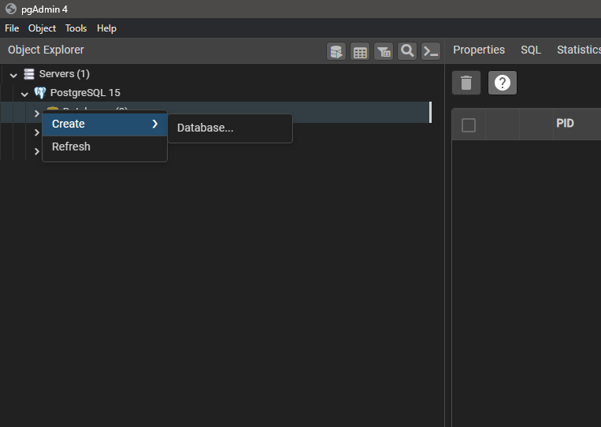

9. Enter the name of the database which is “art pieces db” and click save

10. Click on the the “art pieces db” and open the query tool

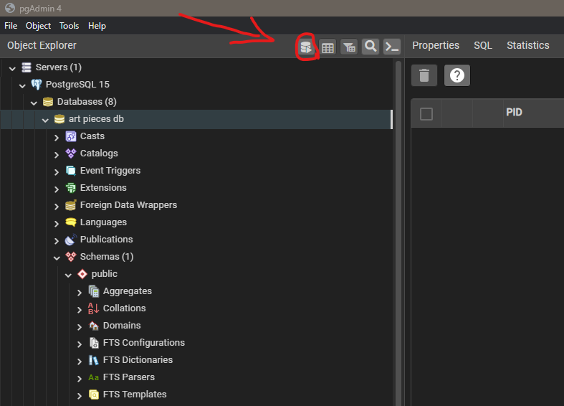

11. Select the option to open a file and navigate in the to the sql script folder and open the “table creation.sql” file and execute the query.

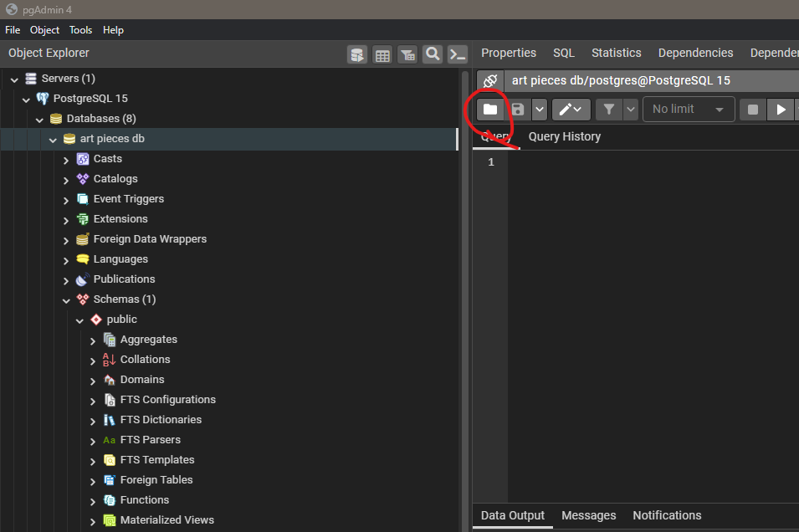

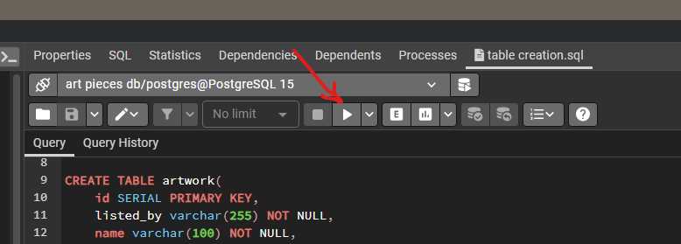

12. With that the database will be created and then the final step is to open the project in Eclipse in the “communications” package in the database class there is a variable at the top of the file called “DB_Password” where you need to insert the password that you created for postgres.

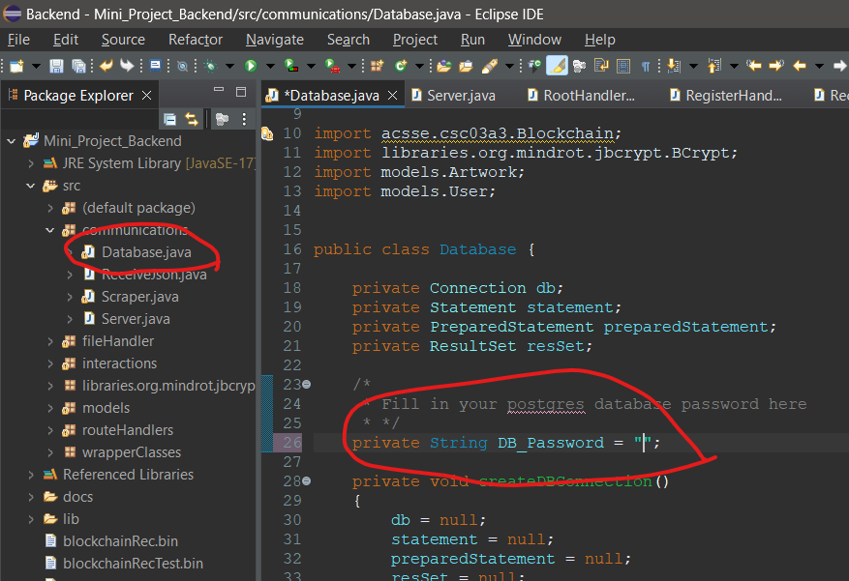

You can then run the backend and now I will go over how to start the frontend.

How to run the frontend

1. Ensure that you have Node.js installed – if not there is a folder in the “Frontend” folder called “Node Installation Guides” In it there are files detailing the installation process.
2. Open the terminal and navigate to the Frontend folder then type “npm i” and hit enter.

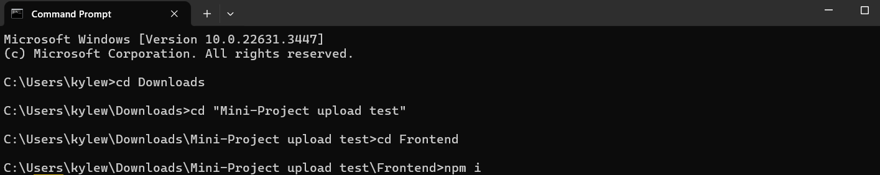

1. This will install all the dependencies needed to run the website and it may take a few minutes.
2. Once it is done type “npm start” and hit enter this will start the website and it will automatically open your browser on the website once its completed.

1. Note it is important to start the backend first but if you didn’t you will get an error on the site but that’s ok, once the backend does start just hit refresh and it should be good.

I apologize for any inconvenience this setup process may cause and I thank you for your patience. If you get stuck at any point in the setup process, feel free to email me: kylew0409@gmail.com.